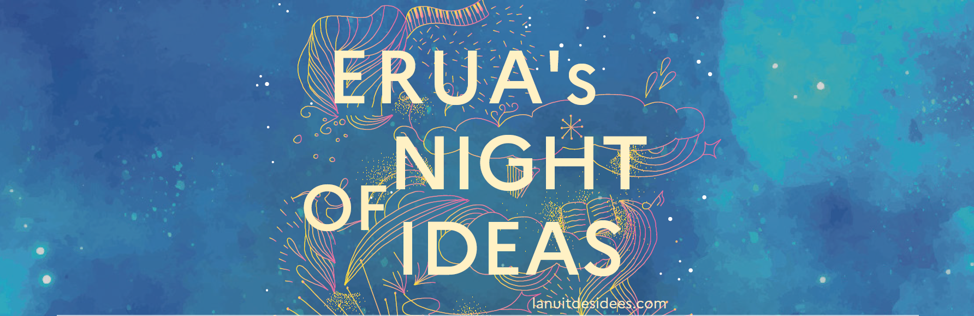

Presentation of the Contributors

7:20 – 8:20 CET
Session 3: Plus de monde ! / More people! / More than one world or no more of one world!

Penser la fin du monde pour envisager d’autres modalités d’être au monde et promouvoir la pluralité citoyenne, en nombre. Faites-les entrer !

Let’s consider the end of the world and imagine other ways of being in the world and promote the plurality of citizens. Bring them in!

Chair panel : TBC

Talk “Oxygenating Community Bonds: Creative Challenges of Social Ecology”

This talk presents the latest edition of the Kids Session in the framework of the Duos Festival of the European project TPAAE - Transcultural Perspectives in Art and Art-Education (https://tpaae.eu/), which took place in February-March 2023 in Kenya. Social Ecology (Bookchin, 2006) was the theme of the Festival, interpreted by artists and researchers through different theoretical-practical approaches. The experience contributed to rethinking lifestyles and research practices in ecological transitions. The community perspective was developed through cooperation with educators, university students, and kids. The collective approach oxygenated the research, through several field experiences, enhancing interdisciplinary, intergenerational, and intercultural competencies. During the Kids Session, more than 100 participants investigated the theme of Social Ecology using various artistic languages, exploring territories, making videos, taking photographs, drawing, painting, and experimenting with cooperative games. The activities took place intensively for three weeks, mainly outdoors, in the rural and urban centers involved.
Kids and teenagers expressed their creativity as protagonists, expert connoisseurs of the environment, and part of dynamic communities; the students deployed their knowledge and soft skills; the educators and the researchers supported the actions by decolonizing knowledge and research practices (Thiong'o Ngugi, 1986). The kids experimented with group dynamics, reflecting on the balanced human ecosystem and developing proposals for Social Ecology in their life contexts, discovering themselves as part of the eco-social milieu, and being able to self-organize forms of cooperation. The field explorations activated the co-construction of critical thinking on environmental and relational inequalities, in close relation to (g)local socio-ecological dynamics. The outcomes of the creative activities were shared in exhibitions and community events, consolidating a dialogue based on awareness, co-responsibility, and educational planning (Freire, 1968) between Africa and Europe, deconstructing stereotyped visions of cultures and knowledge and opting for ecological forms of thinking.

Rosita Deluigi
Rosita Deluigi is an Associate Professor of Education at the University of Macerata, Department of Education, Cultural Heritage and Tourism, where she teaches General, Community, and Intercultural Pedagogy. Her research focuses on:
• Dialogues between cultures - educational processes/working practices with foreign minors; social-community participation; cooperative experiences through creative-expressive languages.
• Ageing and intergenerational dialogue - longevity and active aging; intergenerational experiences; home-care and care workers.
• Design of educational services for children (0-6 years) - inclusive inter-institutional policies.
• Training of professional educators - soft skills; cooperative dynamics; storytelling in social work.
She is involved in several European projects (with EU and non-EU partners) as a member of the research team or as a local coordinator. She is the scientific supervisor of national-local projects funded by the Ministry of Education, Labour and Social Solidarity, public bodies, and private foundations.
In all fields of investigation, she uses ethnographic methods and action research.

Talk - More sensual intuitions!

I still remember this striking impression, as if I were leaving arid, rugged steppes, to find myself suddenly in a kind of 'promised land' of luxuriant treasures, multiplying infinitely’ [1, p. 48-49, transl. A.P.]).
At the heart of our mental activity, representational momentum and boundary extension open up at every moment a virtual space of infinite extension [2], from elementary visual perception to the most abstract spheres of mathematical thought [3].
How is such an ‘extension of presence’ beyond our window of consciousness possible? [4] Why do we experience such prodigious extensions of the mental universe, whether in the course of an erotic encounter, an aesthetic experience or a scientific insight?
Sensual intuitions illuminate the power of experiences that are at the crossroads of embodied reality and imaginary spaces, and whose intensity is likely to open an infinity of mental doors, attractive horizons and desirable directions.
Armed with such tools, we'll embark on a journey into all possible worlds: mental time travel, fictional immersion (novels, films, theater, virtual reality...), playful exploration (pretense, games), penetration of mental worlds (mind-reading), mind-wandering, aesthetic navigation, spiritual travel... We shall attempt to ward off the 72 dangers that await the mental navigator [2]: night, fog, drift, storm, scurvy, octopus, sirens, Intenable, abyss... Don't be afraid, we'll have Homer and Dante as our guides to anchor in paradisiacal islands!

References
[1] A. GROTHENDIECK, Récoltes et semailles – Réflexions et témoignage sur un passé de mathématicien, I, Paris, Gallimard, 1983-1986/2021.
[2] H. BERGSON, Matière et mémoire, Paris, Presses Universitaires de France, 1896/1985.
[3] A. PLAGNOL, Principes de navigation dans les mondes possibles, Garches, Terra Cotta, 2023.
[4] A. NEWEN, L. DE BRUIN, S. GALLAGHER (eds), The Oxford handbook of 4E cognition, Oxford, Oxford University Press, 2018.

Arnaud Plagnol
Arnaud Plagnol is professor of psychology at the Université Paris 8 Vincennes Saint-Denis, M.D., Ph.D2. in philosophy and cognitive science, member of the Laboratoire de Psychopathologie et Processus de Changement (University Paris 8), research associate at the Institut d'Histoire et de Philosophie des Sciences et des Techniques (University Panthéon-Sorbonne) and at the Institut la Personne en Médecine (University Paris-Cité), psychiatrist attached to the ESAT COS-Regain (Paris 13th arrondissement). His research focuses on navigating possible worlds, subjective universes and dangers of mental life, models of psychological care based on the potentials of the persons being cared for.

Talk - Cooperative, Coop de Masques

As part of an ERUA research project, Katia Dupret and I investigated the case of a cooperative, Coop de Masques, created during the pandemic in 2020, that went bankrupt after three years of life only. We were struck by the galvanized energies and elective affinities displayed in the early times of the cooperative, followed by a lack of inventiveness in the face of production problems, finally by the lack of outside support when the cooperative needed it to survive. In the end, all actors were full of regrets and remorses, they also blamed free trade and Chinese mask imports. A documentary movie was made by Simon Coss, in the early period of the cooperative called “For five cents less”. With Katia, we had decided to go back to the site I had observed as a cooperator and board member and interview people looking back at the past. Now, with my colleagues from Paris 8, I also look at an existing cooperative project located in Pantin founded by Jean-Luc François It supports creators in the field of fashion and luxury. Usually, creators prefer individual ventures to compete in a very tough environment. Here, as these creators do not have all the resources they need, they are happy to find support in the incubator and cooperate. Using fieldwork and short documentaries, I describe the type of cooperative actions that take place in this shared space. I also analyse the type of goods produced: they are all original creations by groups with very specific, complementary skills. Looking back at the creation of this structure, there were many obstacles in the way, in the beginning. Yet now the cooperative venture is a success. I hope the comparison is a way to better understand in what conditions cooperatives of production may succeed.

Elen Riot
I am a researcher in organization studies. I am interested by creators, entrepreneurial ventures and cooperatives. I am a member of the LED (Laboratoire d'Economie Dyonisien) and I lead several research programs related to these topics.

Video - Less is more. But what’s MORE?

The concept is revolving around a group of university students who, in our consumerist society, are trying to find their own path, to resist the instinct of crowd but believing, that “Less is more. But what’s MORE?”. The students come from diverse backgrounds, each representing different aspects of the quest for "MORE" in their own lives and how university stands in this way of exploration in life.

MRU Student Community
We will represent Mykolas Romeris university - the largest social sciences specialized university in Lithuania, whose most prominent studies and research areas are: law, public security and public administration.

