

Presentation of the Contributors

6:30 – 7:20 CET
Session 2 : Plus d’humanité ! / More humanity (humaneness) / No more humanity!

Comment penser l’anthropocène, le post-, le trans- et le non-humain ? L'Anthropocène est à la fois une menace et une opportunité pour réfléchir, prendre conscience et agir collectivement. Redéfinissons l'humanité !

How can we think through the Anthropocene, together with the post-, trans-, and the non-human? The Anthropocene is both a threat and an opportunity for reflection, awareness and collective action. Let's redefine humanity!

Chair panel : TBC

Talk - Humanism? No more! More-than-humanism, now!

Against the hope for more humanity or more humaneness, this talk explores the paradoxes and dangers of the ‘human’ signifier and of the concept of humanism.
The Era of the Human – or Anthropocene – has begun. As a first paradox, the time of the increased power of humans over nature has brought forth a new vulnerability of humans to the force of nature. As such, we have started to experience the effects of their own in/action on the world. But what world is this, whose world, and for whom? Cui bono? Who does it benefit? How can it be that the humans who caused this, mostly wealthy white men from the centres, aren’t the ones who suffer most from it? Tragically, the Anthropocene strikes poorer populations, among which women, BIPOC, especially those from the margins.
Surely, notions of Androcene, Capitalocene, or Plantationocene, highlight the situatedness of responsibility in the environmental crisis. But it might well be that Anthropos is an empty signifier: beyond the mirage of colour-blind and gender-blind universalism, the “Human” is an operator of division and hierarchisation. Sadly, in our world, some lives matter more than others. This begins with nonhuman animals, whose treatment founds the dehumanisation of migrant, Muslim, trans, queer and disabled people, to name just a few. As such, we are in need of alternatives to humanism.
Crossing the different historical alternatives and critiques of humanism, we will explore a second paradox, in which working against something often means working right against it. In antihumanism, transhumanism, posthumanism and ahumanism, one will find new ways to articulate this non-innocent heritage of humanism, which keeps haunting us, and now more than ever.

Ombre Tarragnat
Ombre Tarragnat (they/them) is a PhD student in Gender studies and Philosophy enrolled at University Paris 8 Vincennes Saint-Denis, attached to the Laboratoire d’Études de Genre et de Sexualité. A student of Judith Butler’s philosophy of the body and Donna Haraway’s “multispecies trouble”, they recently published articles taking these as a foundation to think antispeciesist ethics and activism, which can be found online. They are currently devoting their doctoral research to the intersection of animal studies, posthumanism and neurodiversity studies, with a project entitled “Autism as Ethodivergence: Philosophical Ethology, Posthumanism, Phenomenology”. Working with descriptions of being-in-the-world (or the lack thereof) through the figure of the “autistic”, they offer to shift them towards posthumanist discourses on embodiment. Far from a lack of connection to the world, they define autism as a dynamic embodiment style characterised by intense experiences of pleasure and pain with non-human beings and the material environment.

Talk - More long-term and interdisciplinary to think through the Anthropocene: trajectories of socio-ecosystems

Over the last three centuries, humanity's global footprint on the Earth's ecosystems has increased tenfold, as development has led to growing demand for water resources, land and territories (urbanisation, agriculture, etc.). The term Anthropocene has been attributed to the current geological epoch, marked by the profound and irreversible effects of mankind. But the concept primarily refers to a process rather than an event or tipping point. Numerous scientific communities and various players in society have taken up the concept. The study of the Anthropocene is largely based on the study of socio-ecosystems, which are complex and hybrid Nature - Culture objects. To do this, there are two main scientific hurdles to overcome, as this requires the development of interdisciplinary and multi-scalar approaches. Indeed, analysing the Anthropocene over the long term is an essential way of tackling the current and urgent issues surrounding the relationship between Nature and Society. With this in mind, scientific research is seeing the growing development of systemic and interdisciplinary approaches, combining Geography, History, Archaeology and Biogeosciences, and mobilising new technologies. They enable us to characterise the trajectories of socio-ecosystems that are and/or have been in tension, in different environmental and societal contexts, both in the North and South. This research produces fundamental knowledge in the environmental and heritage fields and is applied (management of environments, resources, risks, etc.). Two case studies, chosen from the Old and New Worlds, will be used in this conference. The first will look at urban and rural socio-ecosystems in the valley of a major European river (Loire River), in the face of flood risks. The second will look at pre-Columbian Mesoamerican socio-ecosystems in the face of fluctuating resources (water, soil, life) within the territories of ancient Maya cities. More long-term and interdisciplinary appear to be key to think through the pre-Anthropocene, the Anthropocene and the post-Anthropocene.

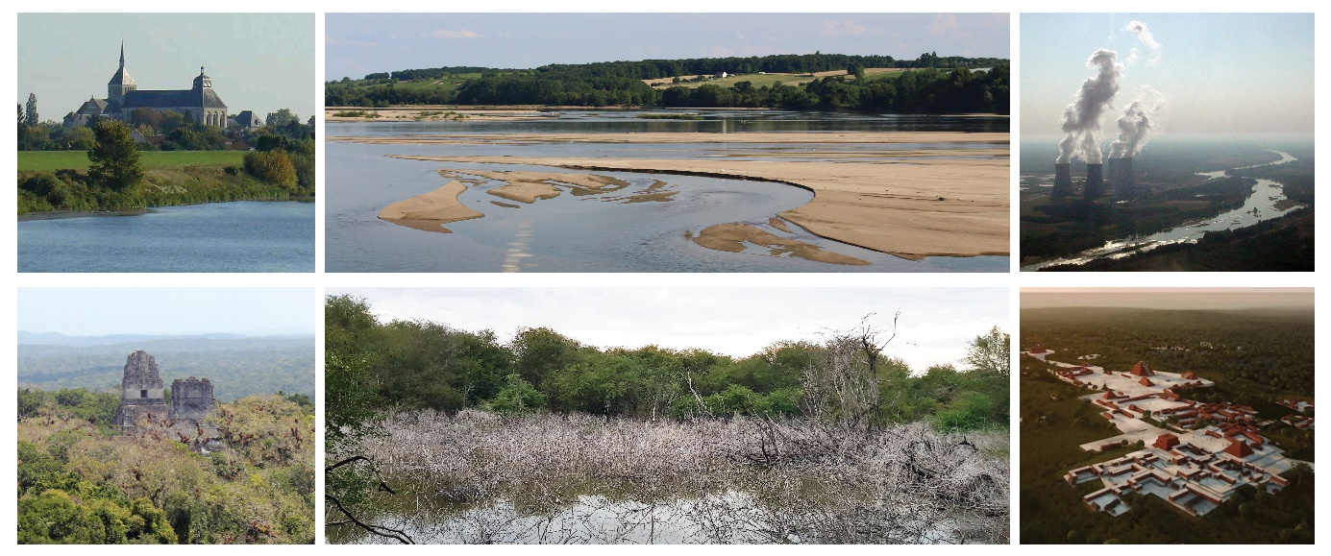

Landscapes of present and past socio-ecosystems, in the valley of a European river (Top: Loire River, France) and in the territory of an ancient Maya regional capital (Bottom: Naachtun city, Guatemala).

Cyril Castanet
Cyril Castanet is a Geographer who has been an Associate Professor at the University of Paris 8 Vincennes Saint-Denis since 2009, where he currently heads the Department of Geography. He specialises in the study of the trajectories of hydrosystems and socio-ecosystems, which he studies using hydrogeomorphological and geoarchaeological approaches. He obtained his Agrégation in Life and Earth Sciences in 2000, and defended his doctoral thesis in Environmental Archaeology in 2008, focusing on the Loire River and the Anthroposystem of the Loire River valley (France). He is developing systemic, interdisciplinary and multi-scale approaches to analyse the dynamics of natural and human-impacted environments and socio-ecological systems in tension, both past and present. He conducts researches on the Anthropocene on the long term, in Europe, Africa and Mesoamerica. He has led and participated in 12 research programmes and has been qualified to lead research (HDR) in Geography since 2022. With his students and other scientific collaborators, he has written 40 scientific publications and presented 90 papers at conferences.

Performance - “Commemorative practices associated with natural history”

While there is now unanimous agreement in the academic world on the anthropological origin of climate change, the Anthropocene is a concept which does not meet with consensus. The precise dating of the advent of this new geological era is far from a matter of consensus. In particular, it calls into question the fixed narrative of a long-standing dichotomy between our Western representations of nature and culture, about which we would finally be the experts.

The aim of my proposal is to provide new input into the debate surrounding this separation between nature and culture, by looking back at commemorative practices associated with natural history, which have recently developed but are still very marginal and little studied: commemorations linked to environmental degradation. New practices have been emerging over the last ten years to commemorate the disappearance or degradation of nature, in a form sometimes similar to what has been studied in numerous cases of national or transnational memorial sites. This is how, in 2019, a plaque was affixed in Iceland to commemorate the disappearance of the Ok glacier, or a ceremony was held to pay tribute to a vanished glacier in Ohio.
Over the past decade or so, the commemoration of tragic climatic events (nuclear disasters, hurricanes, floods, etc.) has fueled the entertainment and tourism industry, in the same way that battlefield tourism has also developed.
I confront our recent perceptions and awareness of the history of climate disruption and its commemorative practices with fictitious older traces, which I fabricate through 10 fake photographs and promotional posters of a grandiose but already derailed natural history. In this way, I parody the entertainment industry's capture of a history of climate that, in the 1950s, fed very little public debate on the anthropogenic origins of its degradation. The effects of this shift are twofold: to make us feel the very late awareness of our behavior towards our environment, and the way in which the entertainment and tourism industries have recently made the theme of climate disruption attractive, often profitable, at the risk of depoliticizing its perception among the youngest generations.

Christine Cadot
Christine Cadot is asssociate prof. in political science. She works on commemorative policies and practices. She works on the politics of commemoration and attaches great importance to visual studies as well as alternative and creative modes of writing in the social sciences.

