ERUA Alliance Project Summary
2023 Erasmus Call + Call for Proposals
Building a renewed ERUA through 3 Specific Objectives and 6 Flagship Initiatives
As a unique European University that focuses on social sciences, humanities and arts and pushes for their interactivity with science, technology engineering and maths fields, ERUA is well placed to contribute to global challenges through innovative and interdisciplinary perspectives. By pooling our individual strengths and past achievements, we will increase our societal impact by creating a powerful academic hub for critical and innovative contribution to a free, more equitable and democratic Europe. We believe that to shape peaceful, just, and sustainable futures, higher education and research must be substantially transformed. Additionally, ERUA aspires over the coming years to be an integrated European community that will collaborate to change the landscape of pedagogical reform, research and service to societies in Europe.
Over the previous funding period, ERUA has re-imagined higher education and research, learning pathways to build an ERUA community and campus with 5 partners. This consortium has allowed us to build a community, promote our critical ideas and develop our sustainable conception of academia.
We have now grown our network from 5 to 8 reformist universities including founding members Université Paris 8 Saint Vincennes-St Denis (UP8, France), New Bulgarian University (NBU, Bulgaria), and University of the Aegean (UAEGEAN, Greece), and expanded to the East and South of Europe with our new partner universities SWPS Social Sciences and Humanities (SWPS, Poland), European University Viadrina (EUV, Germany), University of Macerata (UNIMC, Italy), Universidad de Las Palmas de Gran Canaria - (ULPGC, Spain) and Mykolas Romeris University - (MRU, Lithuania). At the same time, founding members Universität Konstanz (UKON, Germany) and Roskilde University (RUC, Denmark) have moved from being full partners to associated partners.
By establishing our new Mission Statement and harmonising and understanding the needs of our members, for the coming period, we aim to build on our accomplishments (joint strategies and policies, mapping exercise in view of identifying good practices, as well as mobility and community building activities), by focusing on 3 specific objectives and 6 flagship initiatives that draw on the recommendations from the European Commission and external evaluators.
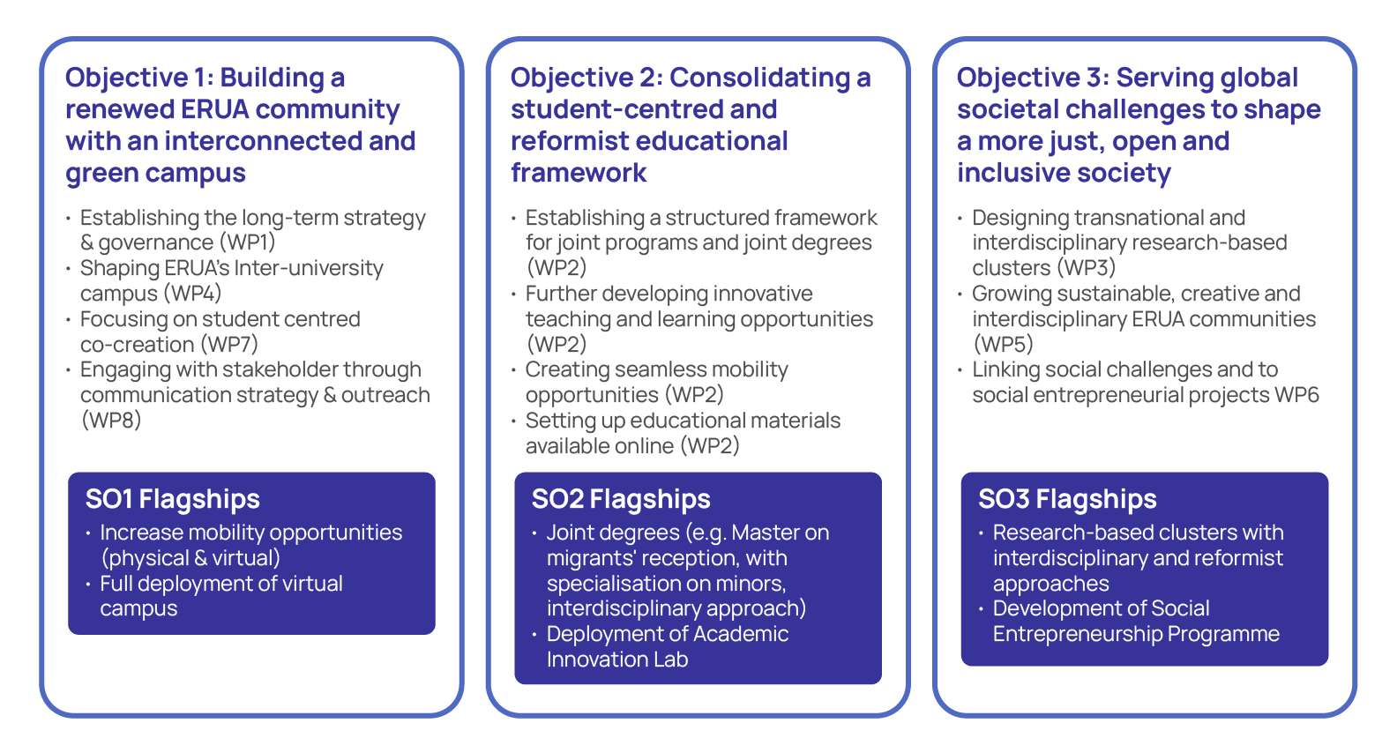
Who is ERUA - standing on the edge
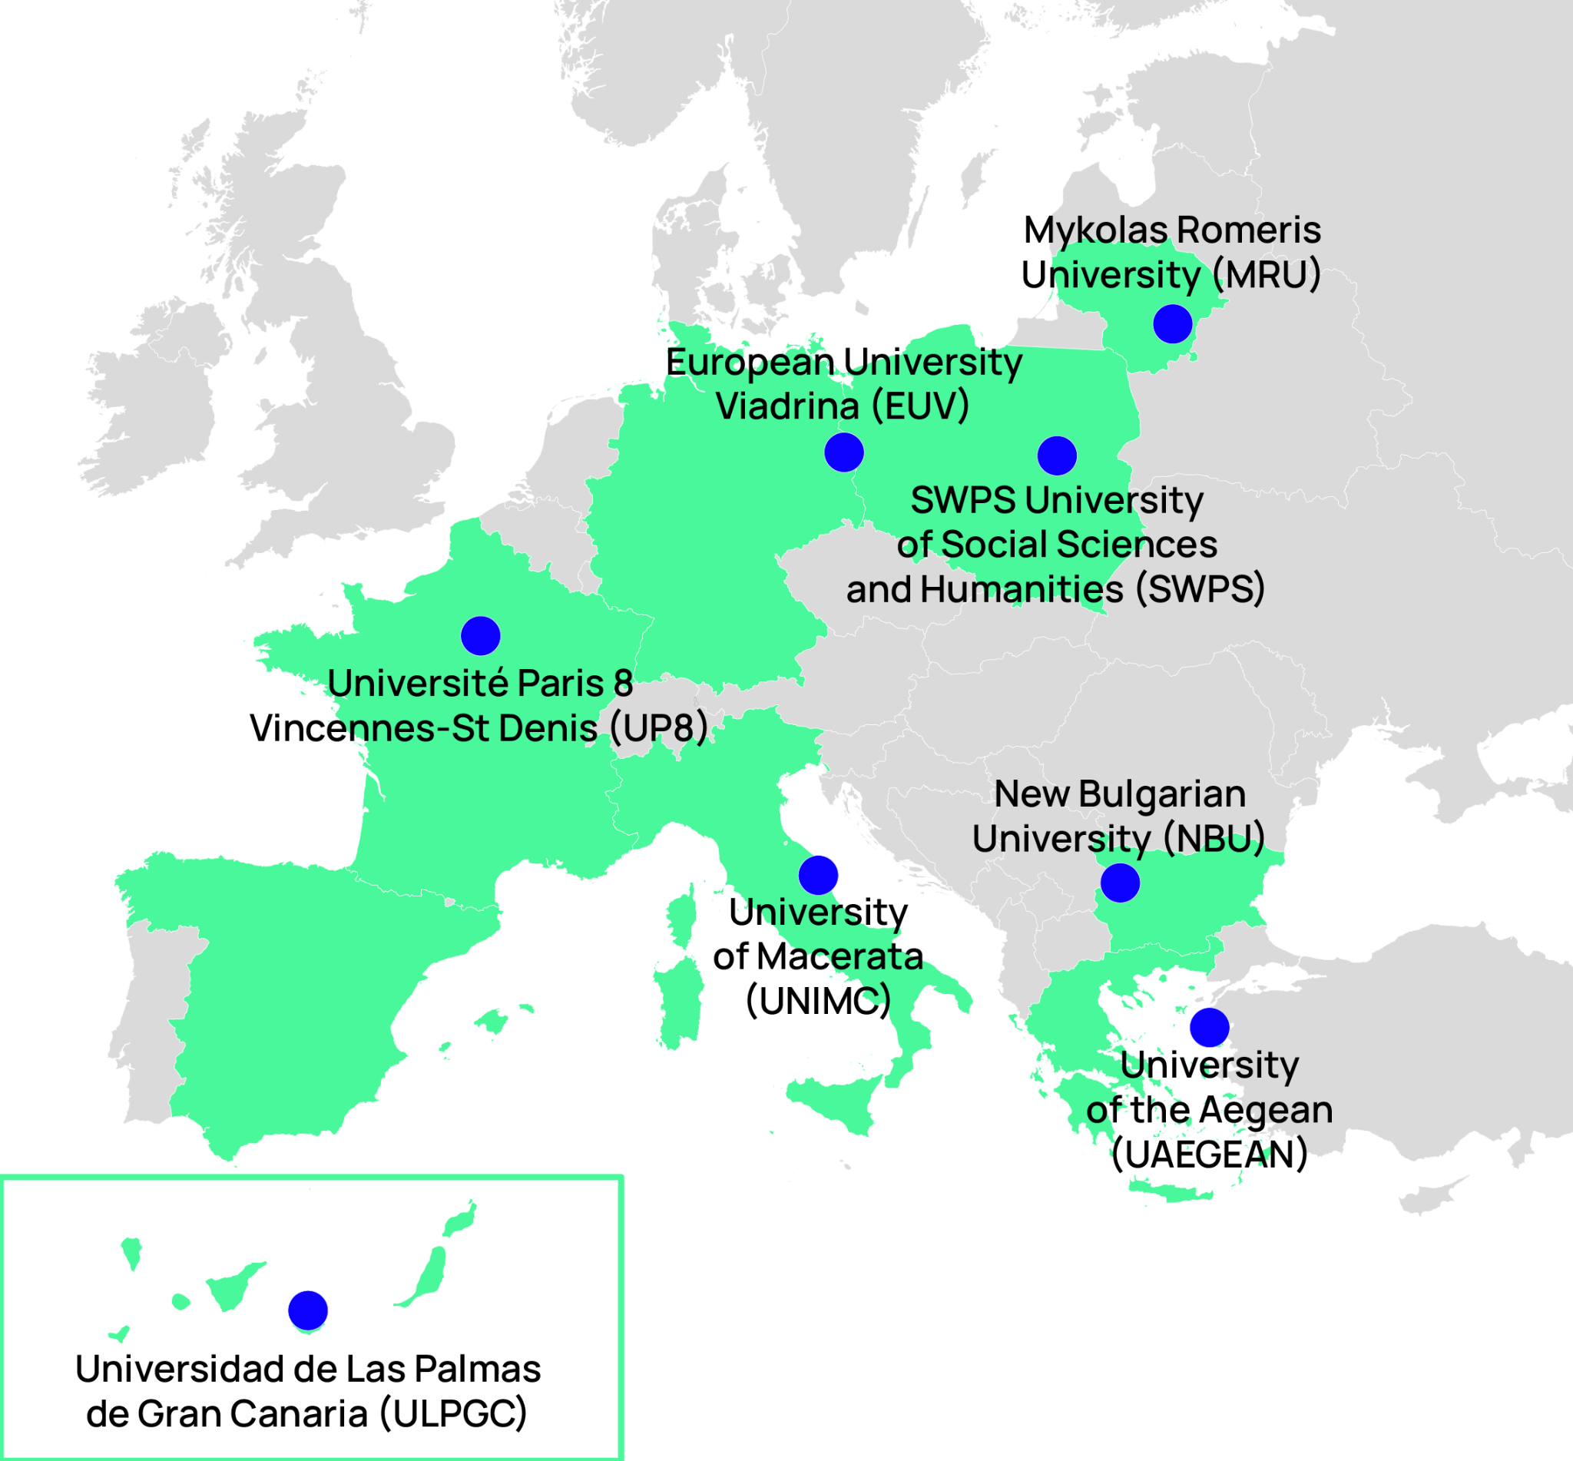
ERUA integrates 8 universities from 8 different countries in Europe’s East, West, North and South with a strong focus on Eastern Europe represented by SWPS and NBU and the South, which is represented by the UAEGEAN, ULPGC, and UNIMC. This focus is balanced in the West by UP8, and EUV, and rounded up in the North by MRU. All our members have a strong background in the Social Sciences, Humanities and Arts, while UAEGEAN and ULPGC also cover natural sciences and engineering. This expansion of ERUA from 5 to 8 partners has been conducted based on common reformist values, existing collaborations, strong affinities as well as geographical balance.
We are young universities, 6 of our 8 members being founded or re-established in the 1980s or 90s. Each was born (or reborn in the case of EUV and UNIMC) out of the need to address urgent problems and challenges, which more traditional universities were unable to tackle or chose to ignore. Those challenges were diverse: the turmoil of political unrest with particular importance of the Humanities and Arts (UP8, UNIMC), geographical isolation and the ensuing need for suitable means for development (UAEGEAN and ULPGC), and the deep changes in the wake of the fall of the Soviet Union (NBU, SWPS, EUV, and MRU). However diverse these challenges, though, they all had in common that they required the respective university to be critical vis-à-vis established ways to work, and established methods of generating impact.
As reform universities, we are thus collectively committed to cultivate an inclusive, experimental, innovative and socially oriented learning environment. Our Alliance is particularly strong in Humanities, Social Sciences and the Arts, and this enables us to develop creative approaches to higher education and research, and through these strong fundamentals, we are ready to fully engage in educational reform. UAEGEAN and ULPGC also provide a disciplinary opening and opportunity to engage in a dialogue with the STEM disciplines within the alliance.
We defend a strong student-centred focus at the core of our academic reform approach and practices. We view ERUA universities as standing ‘on a critical edge’- both in terms of values and geography due to our expertise in educational strategies and partnering nations. Now, stronger together with our common vision, we are in a position to better contribute to the development of a sustainable society, and promote European values throughout our 8 universities.
The enlargement and geographical shift of our consortium have given us the opportunity to sharpen our long-term objectives and our approach to educational reform in our contemporary world. And with our approach of fostering complementarities out of diversity, we will be better able to contribute unique perspectives beyond the Social Sciences and Humanities and enable a dialogue with the STEM disciplines. By this convergence of ERUA universities from Europe’s East and West, North and South, and students from top and lower socio-economic deciles, from rural and urban, insular and mainland settings, local and global backgrounds, we create opportunities to stand ‘on a critical edge’ both in terms of values, geography and social diversity.
Joint work plan 2023-2027: a powerful academic hub to address global challenges
ERUA’s work plan responds to the long-term vision and ambition of the European Universities Initiative and has been co-designed with the partner universities in a collaborative effort to match their strengths, interests, and local strategies to ERUA’s mission, vision and values.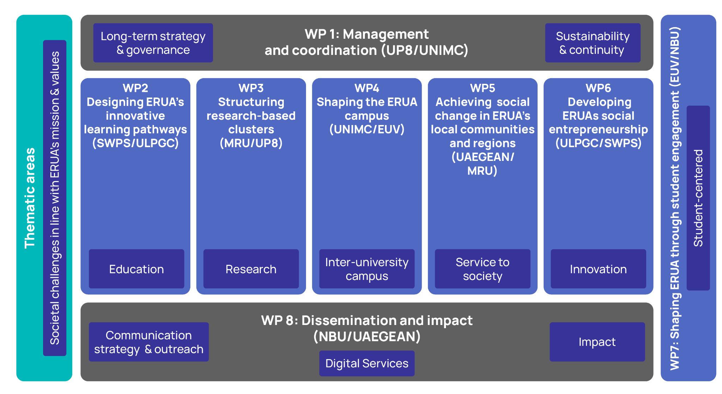
Our plan in a nutshell:
- Four of the work packages have been built around the missions of universities, with WP2 on education, WP3 on research, WP5 on service to society and finally WP6 on innovation.
- The WPs Management and coordination (WP1) and Dissemination and impact (WP8) have a cross-cutting role. WP1 leads the long-term strategy and sustainability of the alliance with a reformed governance scheme and management setup. This enables the successful implementation of the alliance’s joint vision. WP8 leverages our communication, dissemination and outreach strategy to leverage our activities for impact.
- Centrally placed is WP4 with the inter-university campus, which further shapes an inclusive, green and interconnected ERUA community to increase physical and virtual mobility opportunities for students, academic and non-academic staff.
- ERUA upholds its focus on students by incorporating WP7, which empowers students to co-create the ERUA community and educational programmes. This work package will operate across all other WPs.
- Building on the developments and expertise of the previous funding period, ERUA’s digital services (WP8) will be fully deployed and become a central digital hub to provide accessible mobility and educational resources to students, faculty and staff.
- To emphasise ERUA’s mission, 5 transversal thematic areas of specific interest and capacity for ERUA have been added. They address social challenges of importance to Europe and provide focus to ensure that all work packages are working towards enhancing societal impact around the established topic of the Alliance, without strictly limiting the thematic scope.

migration, exile and refugees
environmental transition
democracy & human rights, inclusion & gender equality
interculturality, multilingualism
arts and edges
Our Thematic Areas

Master on migrants' reception, with specialization on minors (WP2)
Young Forum for Action on Climate Change (WP7)
Advocacy group Democracy & Human Rights, Inclusion & Gender Equality (WP1)
Exchange Forum on Social Justice & Intercultural learning (WP4)
ERUA Biennale (WP5)
Example activities
“Reform is making a difference”: our guiding principle to generate impact
In our Mission Statement, we state that “Reform is making a difference”. Following that principle, the generation of impact within and beyond our member institutions and academia as a whole is a core ambition of the project. Our ambition is to generate impact in all of the following dimensions and areas:
Internal impact
Engagement, Content, Processes
External impact
Institutional, Systemic, Societal

A second perspective to approach impact, that forms a matrix with the approach by area, is by target groups. Our approach to impact is based on dialogue, as opposed to the paradigm of the generation of impact as an outward one-way road. This is why we place the involvement of our target groups at the heart of our impact strategy.

Target Group | Specific Involvement in ERUA | Main Benefits
ERUA Students | -Involvement in co-creating the ERUA community and educational programmes (WP7, WP2 and WP4)  - Participation in mobility programmes (WP4)  - Participation in governance bodies (WP1)  - Leading, managing core activities, and networks with local communities as change makers and local activators (WP5)  - Participating in ERUA’s social entrepreneurship initiatives (WP6) | - Benefit from mobility programmes and build a critical and reformist mindset  - Profit from innovative joint programmes that provide competitive diplomas and support the careers of our alumni  - Gaining life experience and skills for social responsibility  - Develop an entrepreneurial mindset and student engagement schemes
ERUA Academic Staff | - Participation in shaping learning pathways and initiatives (WP2)  - Engagement in research-based clusters (WP3)  - Participation in governance bodies (WP1)  - Creation of a teaching and research community (WP4)  - Engagement in Community-Based Participatory research, through Science Shops (WP5) | - Easing and mainstreaming joint applications to EU or other projects under the umbrella of the ERUA alliance  - Increasing attractivity and competitiveness and contribution to addressing global societal challenges  - Building critical mass on specialised topics  - Solving societal problems for local communities and encouraging the integration of digital thinking, sustainability, inclusion, and aesthetics in new solutions and products in region
ERUA Technical and Administrative Staff | - Participation in the construction in the ERUA physical and digital community (WP4)  - Participation in mobility programmes and best practice exchanges (WP4)  - Participation in governance bodies (WP1) | - Improve scope and personal qualification via mobility and exchange for personal growth  - Streamline and ease processes
ERUA Associated Partners | - Involvement of in co-created curricula (WP2)  - Participation in joint research (WP3)  - Activities concerning the  - Participation in activities & initiatives for sustainability and creativity and expanding Creative and Interregional Knowledge Communities (WP5)  - Entrepreneurship programmes including internships (WP6) | - Fostering regional development  - Provide an academic basis for the specific needs of various communities  - Develop human capital at a regional level in particular
Other Higher Education Institutions | - Joint events or collaborations with other European University alliances and HEIs (WP8)  - Access to shared educational resources (WP2)  - Collaboration in activities for local communities and regions (WP5) | - Learning from ERUA’s experience  - Enhancing ERUA’s capacity to disseminate knowledge and to collaborate with external partners and act as a role model  - Joint efforts to increase and achieve transformation and social change
The General Public | - Open innovation initiatives and open digital events, Community-Based Participatory research for communities (WP5) | - Achieve social change in campus, communities and regions

